**Cheque Pay – Cheque Printing Solution**

**Version 1.1.0-fr001** 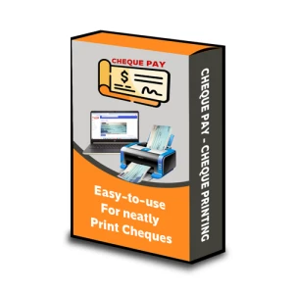

**Table of Contents**

Table of Contents

Overview 4

SuperTime-FaceAndroid 4

Cloud Application 4

Login 5

Home/Dashboard 6

Demo Logs 7

About 8

Multi Language Support 8

9

Profile 9

Settings 10

Change Password 10

Users 11

Database Operations 12

Navigation Menu 13

Masters 14

Devices 14

14

Company 15

15

You can delete Company record information here. 16

Location 17

Area 19

Department 22

Designation 24

Employee 26

Project 29

Shift Management 31

Timetable 31

31

Shift 34

Shift Assigned 37

Leave Management 38

Leave Type 38

38

Leave Assign 40

Leave Request 41

Leave Approval 42

Attendance Reports 44

Daily Attendance 44

Working Hours 45

Attendance Log 46

Salary Report 47

## 

## Overview

**Cheque Pay - Cheque Printing Solution**

The **Cheque Pay** application is a comprehensive cheque printing solution tailored for businesses, accountants, and individuals who regularly issue bank cheques. With increasing digitalization, manual cheque writing can be time-consuming and prone to errors. Cheque Pay resolves these challenges by offering a user-friendly, precise, and customizable platform that ensures professional cheque printing with minimal effort.

Designed to support multiple bank formats and institutions, this solution empowers users to print cheques that conform to bank-specific layouts. Whether the user is printing a single cheque or handling bulk cheque issuance, Cheque Pay streamlines the process with precision and flexibility.

**Key Features:**

* **Customizable Templates**: Upload scanned images of your bank's cheque leaves and define the positions for fields like Date, Payee, Amount in Numbers, Amount in Words, and Signature using a drag-and-drop interface.
* **Multi-Company Management**: Handle cheque issuance for multiple companies under a single user account. Each company can maintain its own templates, bank accounts, and payee information.
* **Multi-Currency Support**: Supports printing in different global currencies (e.g., INR, USD, EUR), including localized amount-in-words generation.
* **Preview & Print**: Users can preview cheques with actual data before printing, reducing errors and avoiding cheque wastage.
* **Cloud or On-Premise Deployment**: Flexibility to deploy Cheque Pay on a local server or cloud, based on organizational requirements.
* **Security & Licensing**: Licensing features are built-in to control usage, ensuring that only authorized users and devices can access company data.

**Customization:**

Cheque Pay allows advanced customization of fonts, sizes, styles (bold, italic), and positioning for each text field. These settings can be saved per template, offering a high degree of flexibility for institutions with unique formatting standards.

Additionally, users can add background logos, watermark overlays, or include authorized signatory lines where applicable. The application ensures that each cheque appears uniform, professional, and aligned to the bank's clearance standards.

**Use Cases:**

* **Small and Medium Enterprises (SMEs)**: Manage multiple accounts, banks, and payees without depending on pre-printed cheques.
* **Chartered Accountants & Finance Professionals**: Print cheques for multiple clients while maintaining a record of issued cheques.
* **Personal Finance Management**: Individuals can track and print cheques with ease, avoiding handwriting errors and maintaining clarity.

**Technical Notes:**

* Built using Django (Python) on the backend for high reliability and security.
* JavaScript-driven front-end for dynamic UI interactions, including drag-and-drop text placement.
* MS SQL Server or SQLite for flexible database options depending on deployment scale.
* Compatible with standard A4/cheque printers and supports margin calibration for precise output.

**Advantages of Using Cheque Pay:**

* Reduces cheque handling time by automating formatting and positioning.
* Minimizes human errors such as spelling mistakes, misplaced text, or wrong amounts.
* Centralizes cheque records for better auditing, traceability, and reporting.
* Ensures professional output, enhancing brand credibility and presentation.
* Easy-to-use interface requiring no technical background or design skills.

# 

# Cloud Application

URL : http://217.165.4.226:90/Chequepay/

## Application Flow and Contents

The flow of application and its contents is explained below using images and simple applications.

## Login

You can login using the information provided via email, such as, registration code, email and password. And if given wrong credentials it will show error.

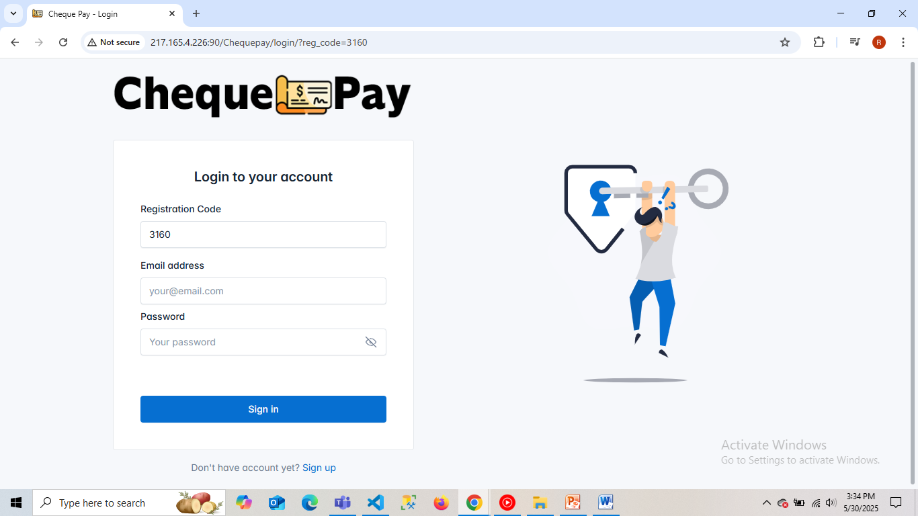

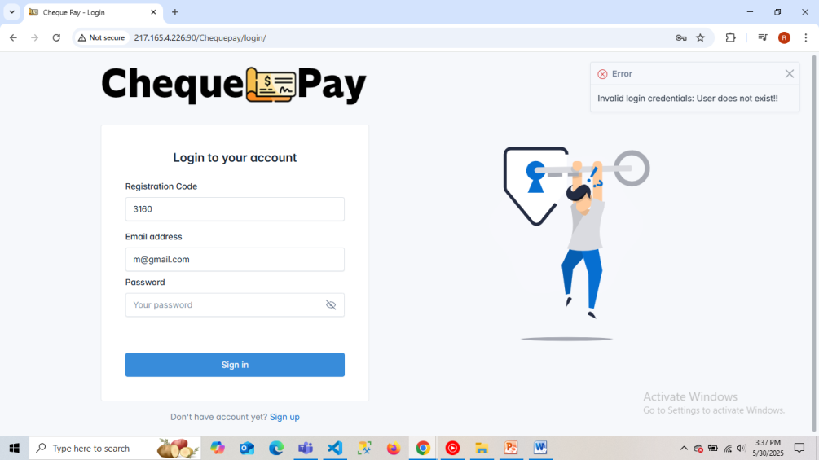

## Wizard

When logged in the first time, a dialog box will open asking to start the setup. This will allow the user to enter the single initial values needed to carry on the application.

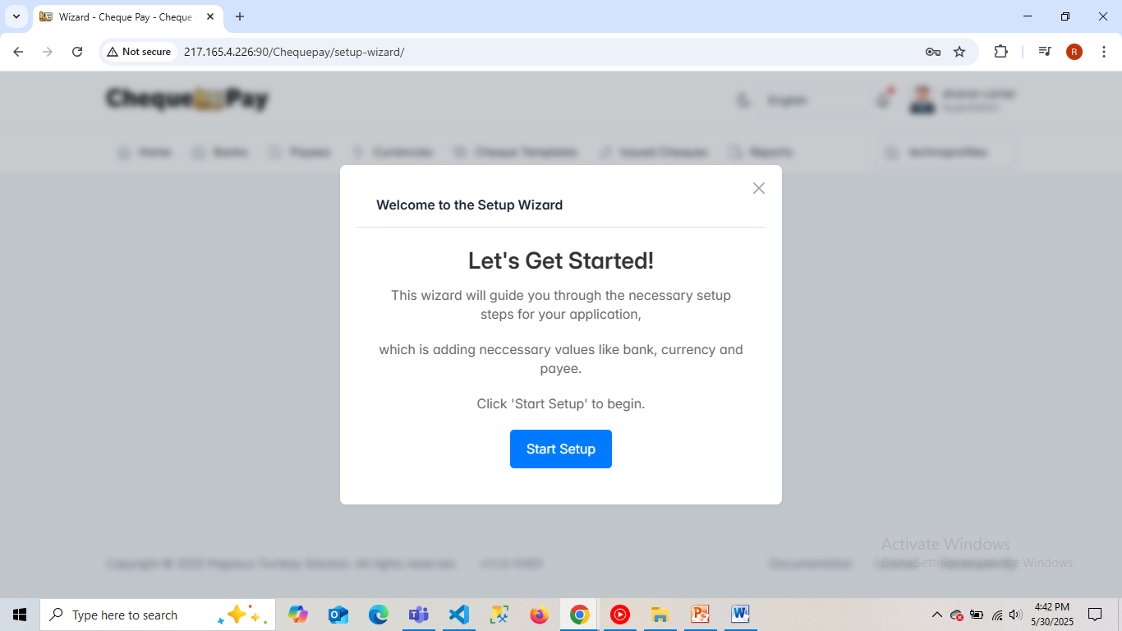

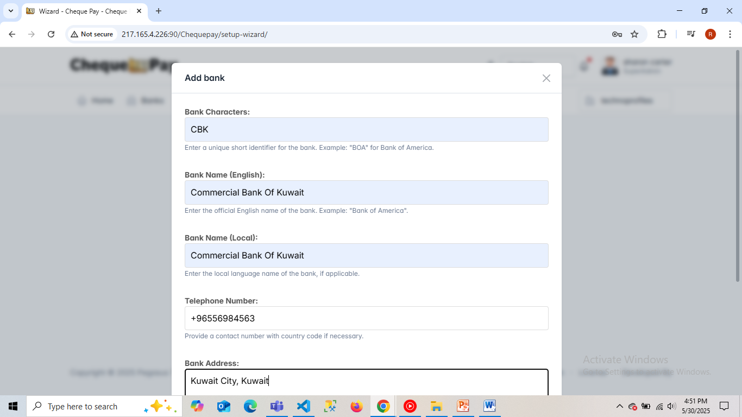

## Home/Dashboard

After completing the wizard part the user will come to the **home.** This shows an overview of the application and the contents present in the application. Such as count of –

* Banks present
* Payees exists
* Currencies
* Cheque templates created
* Cheque issued
* Cheque pending for approval
* Cheque approved
* Cheque rejected

Also it also represents certain data in the form of pie chart. Such as –

* Total transactions via multiple currencies
* Number of templates via different banks
* Number of Cheque approved from different banks

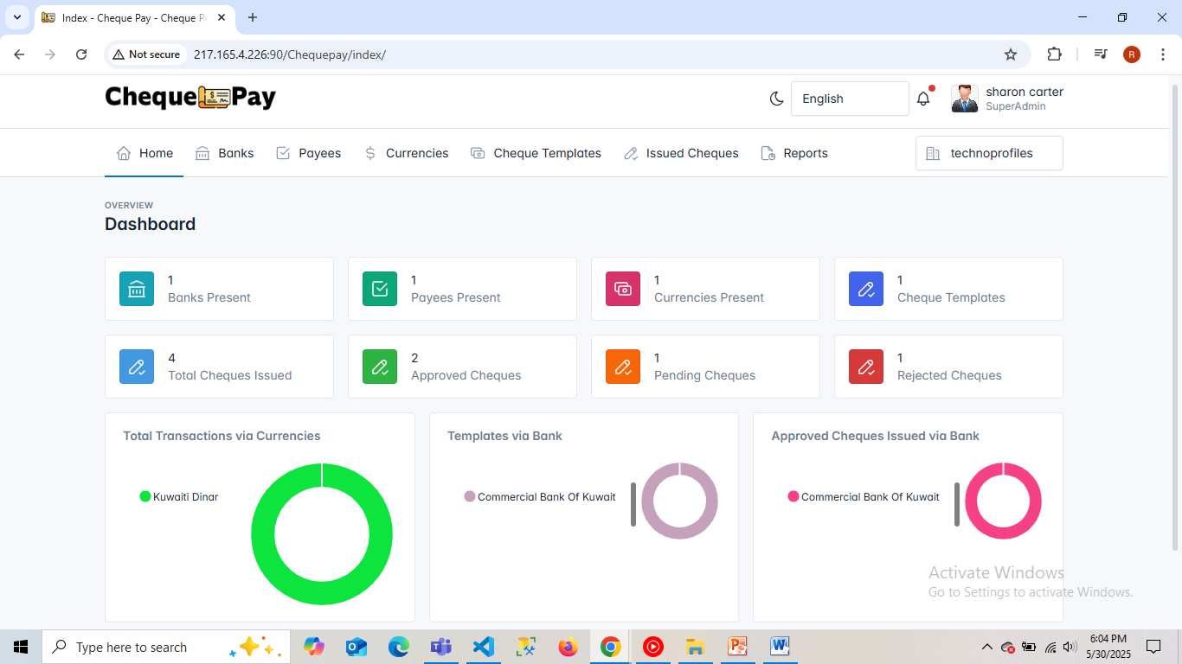

* **Banks**

This option shows the details of the banks present in the application and manipulate the existing data, add or remove it.

* Bank list

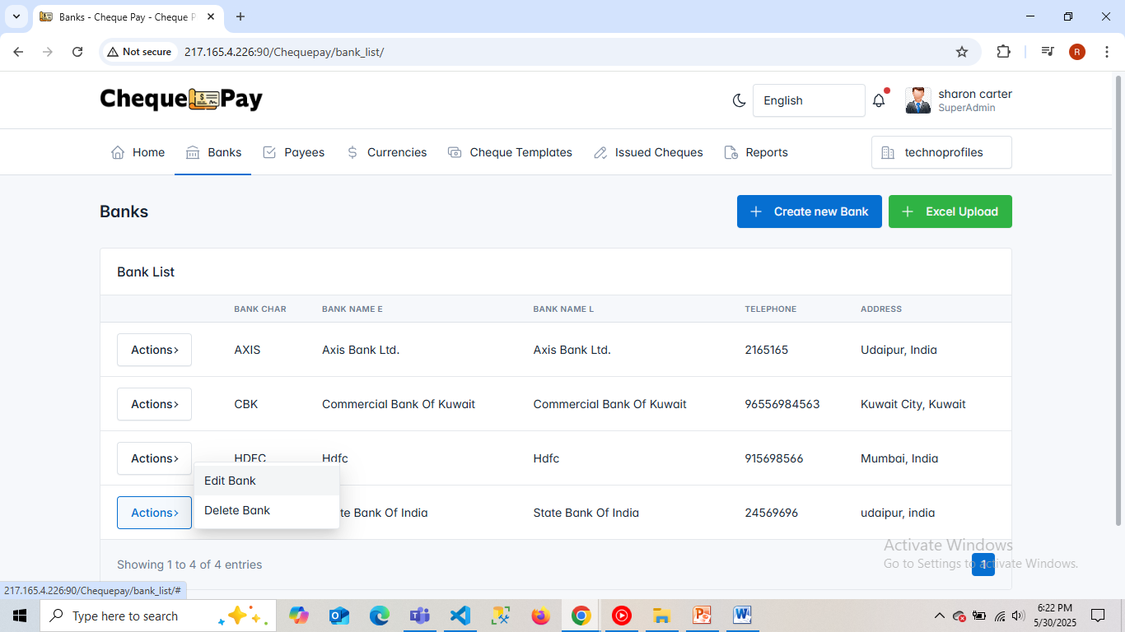

* New form

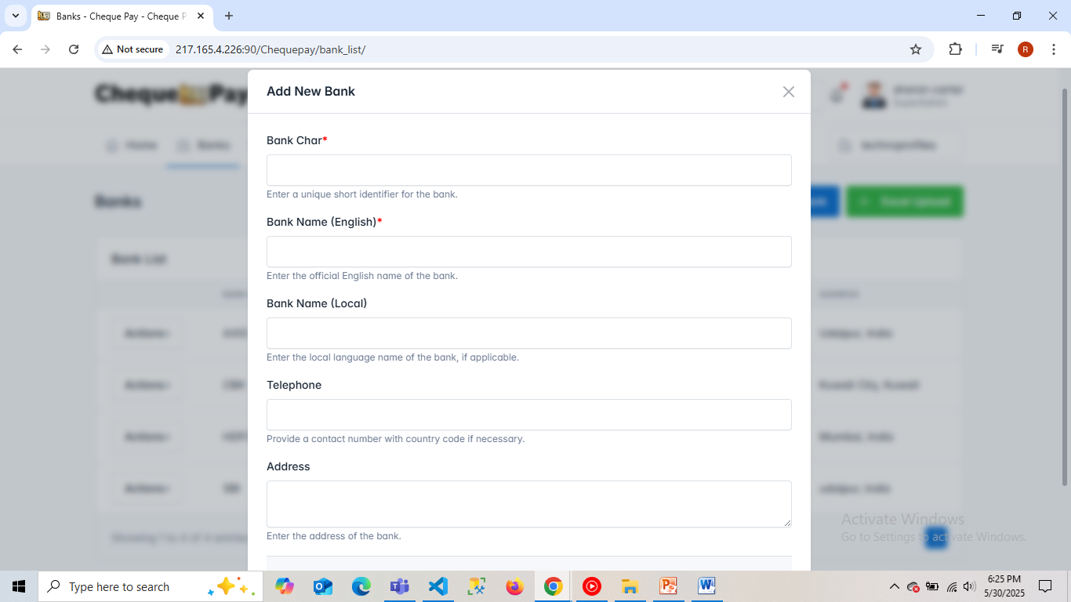

* Edit form

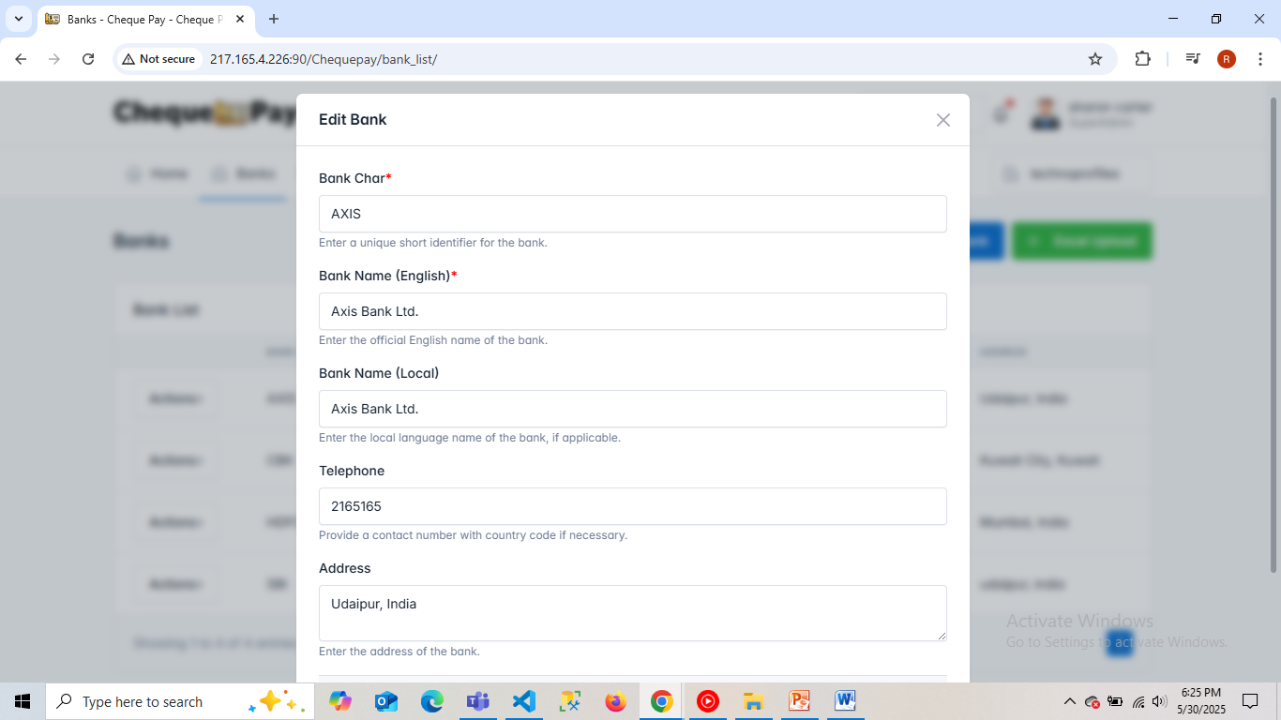

* Upload new banks via MS Excel file

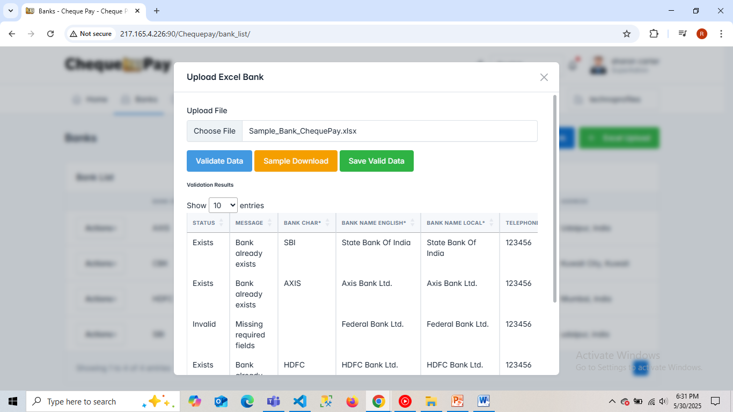

* **Payees**

This option shows the details of the payees present in the application and manipulate the existing data, add or remove it.

* Payee list

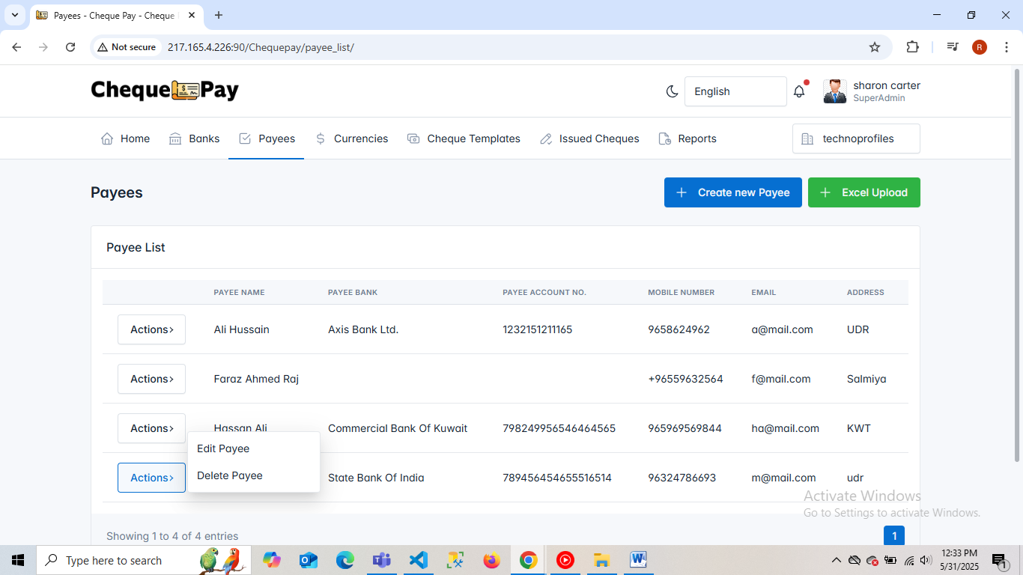

* New form

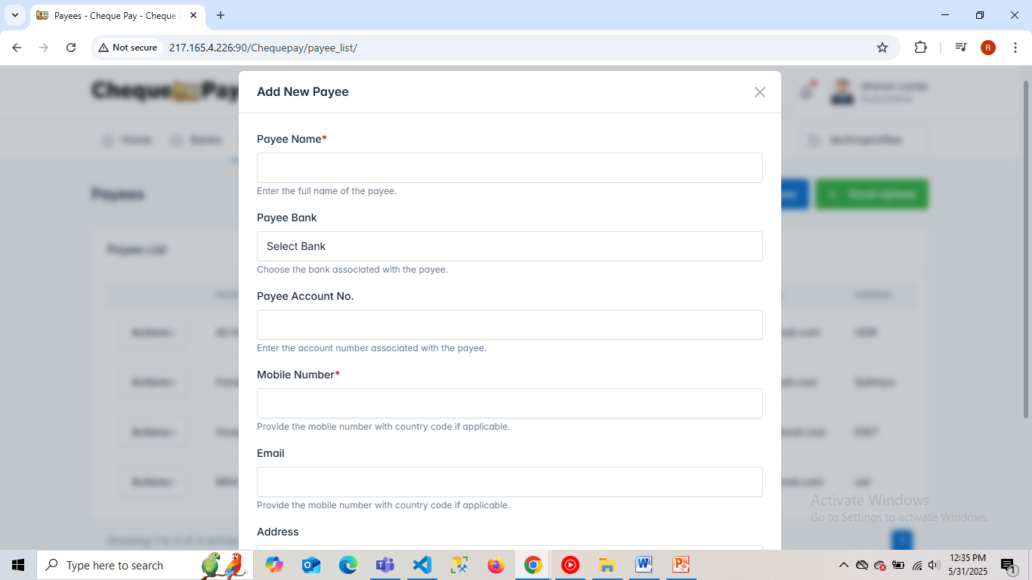

* Edit form

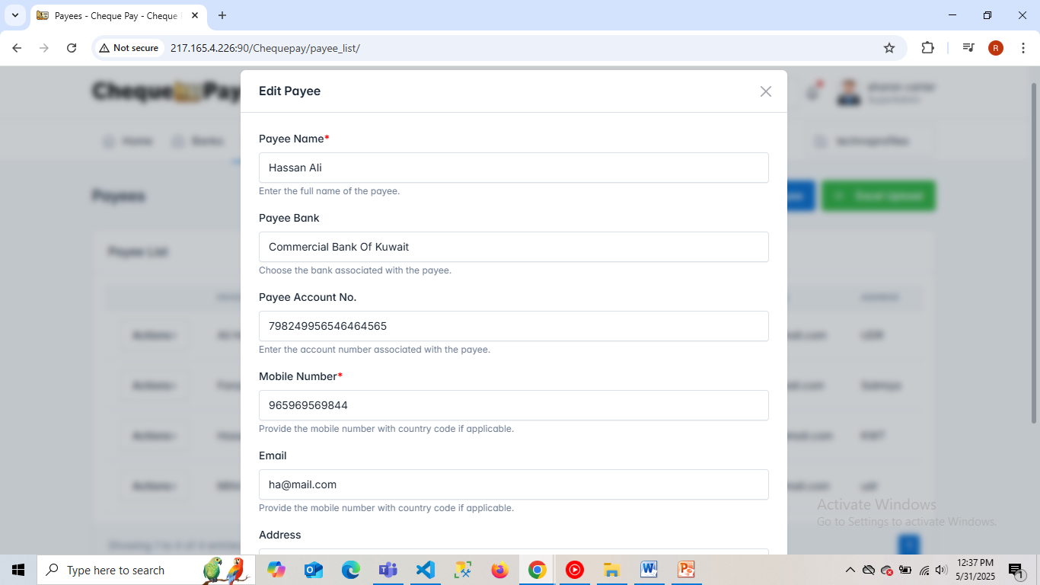

* Upload new payees via MS Excel file

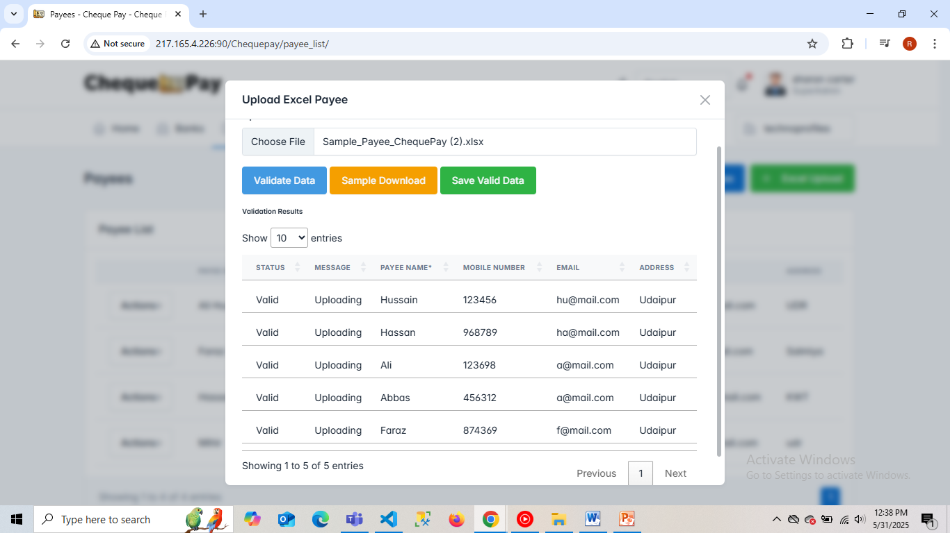

* **Currencies**

This option shows the details of the currencies present in the application and manipulate the existing data, add or remove it.

* currency list

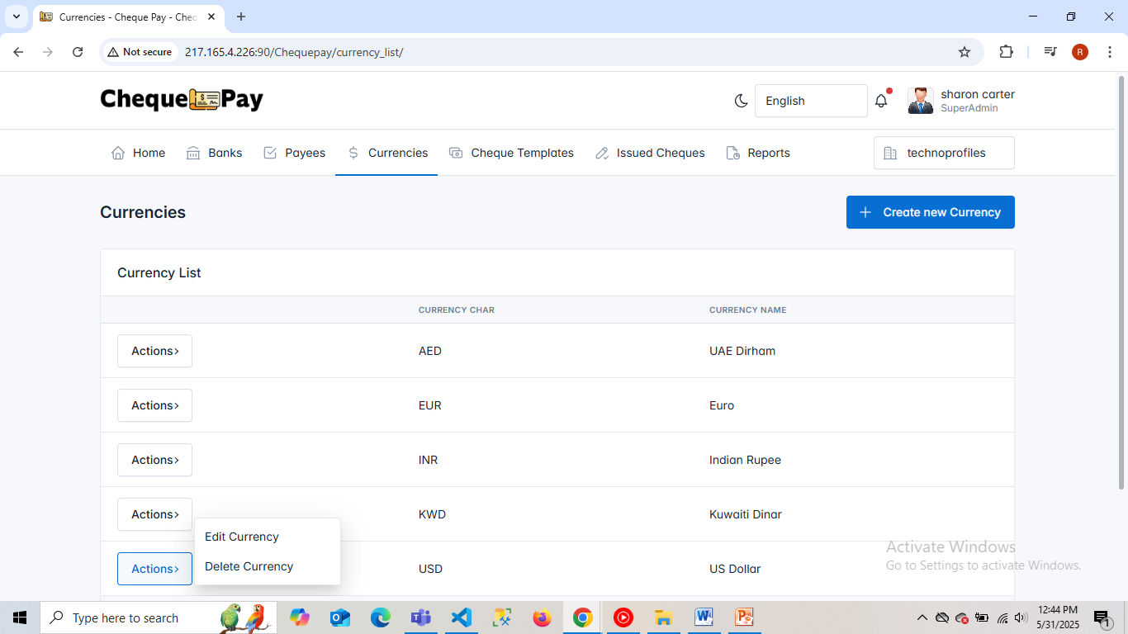

* New form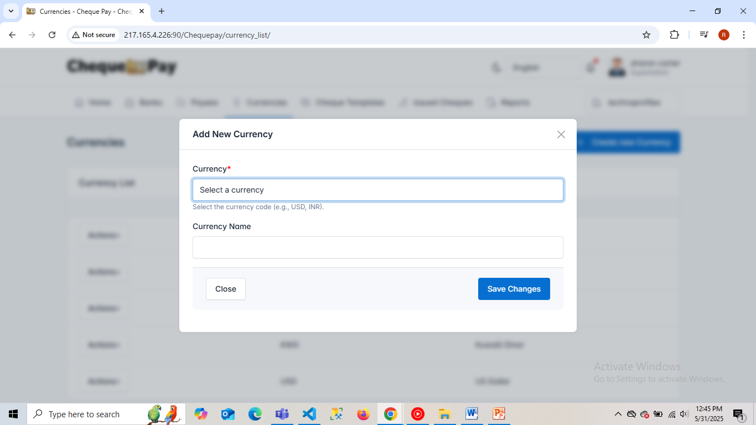
* Edit form

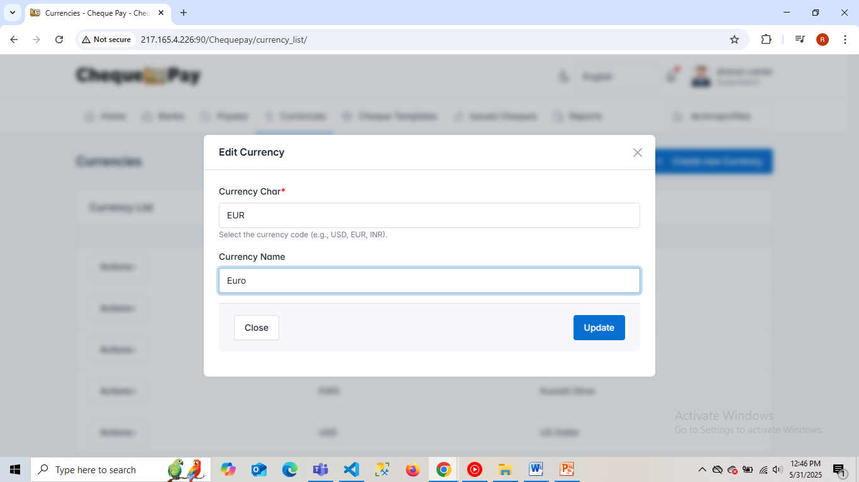

* To delete any existing currency.

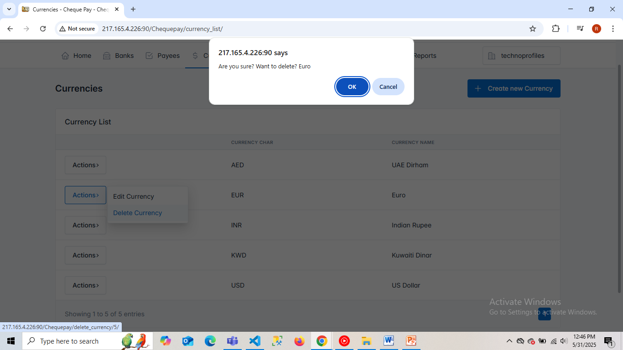

* **Cheque Templates**

This option shows the details of the Cheque templates created to issue and print Cheque according to the need. Also one can set the text positions and manipulate details.

* Template list

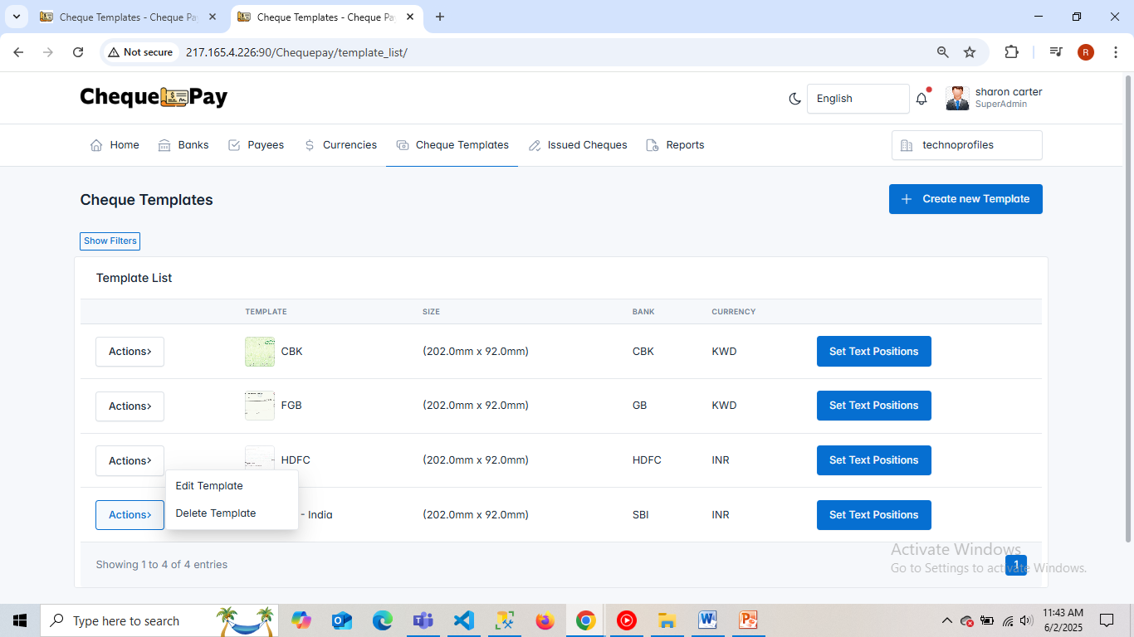

* New form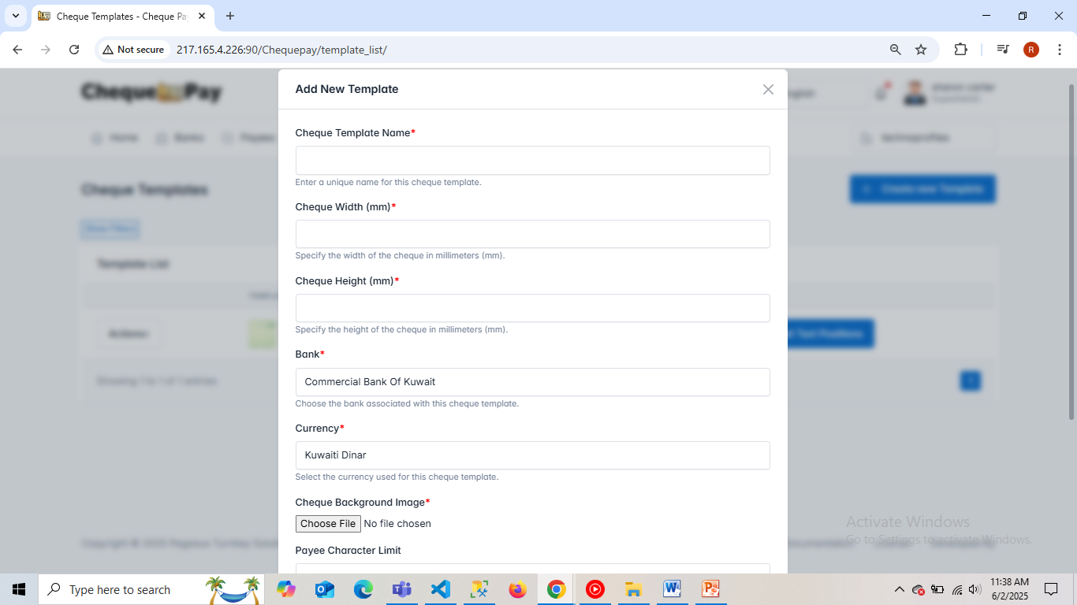
* Edit form

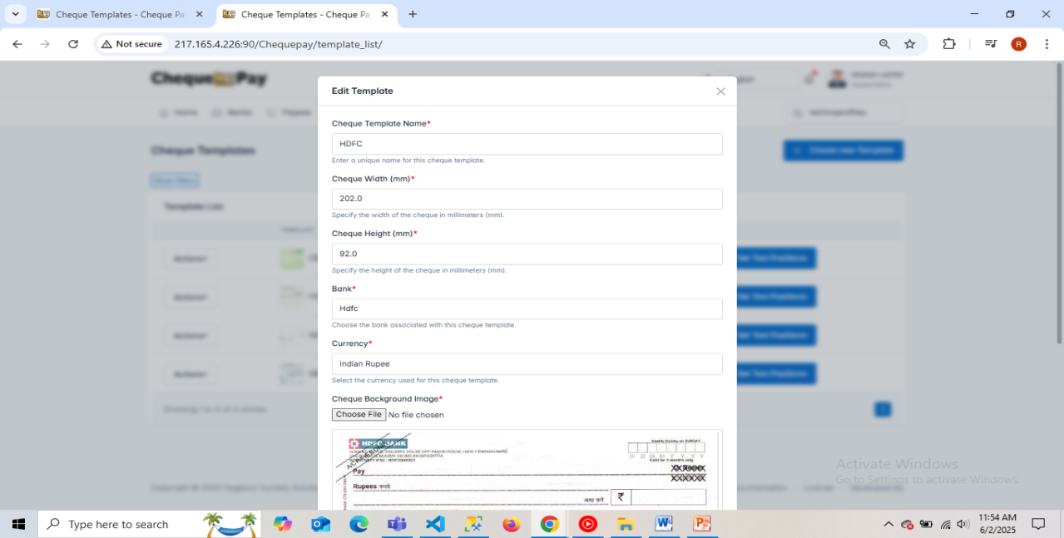

* To delete any existing Cheque templates.

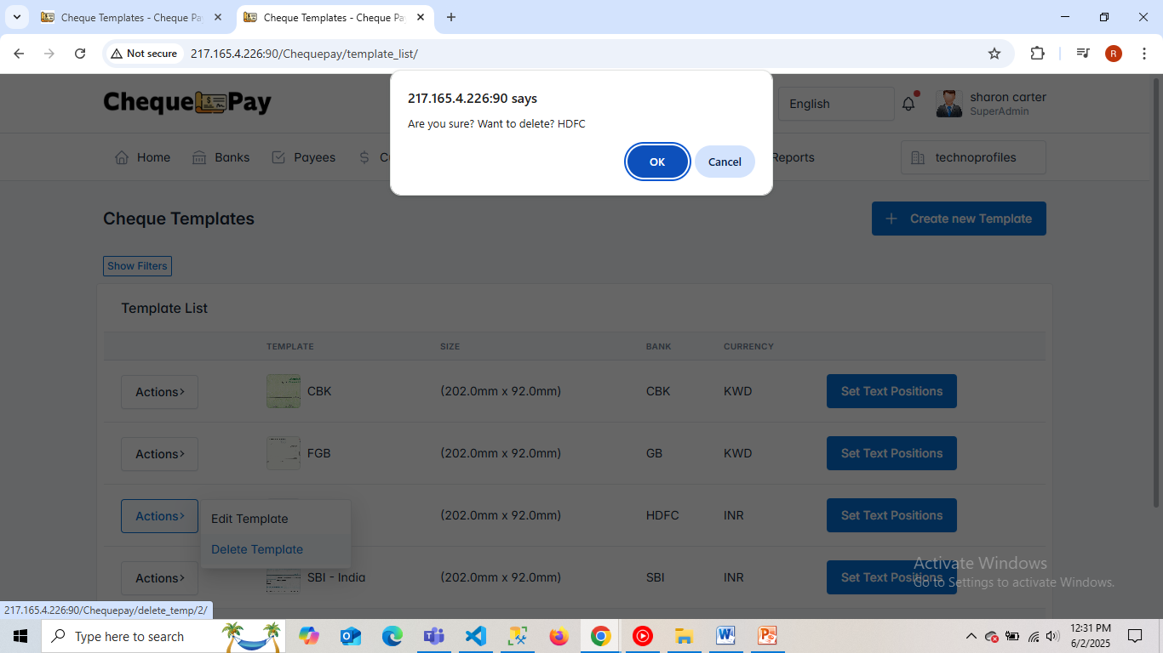

* Set text positions on Cheque template

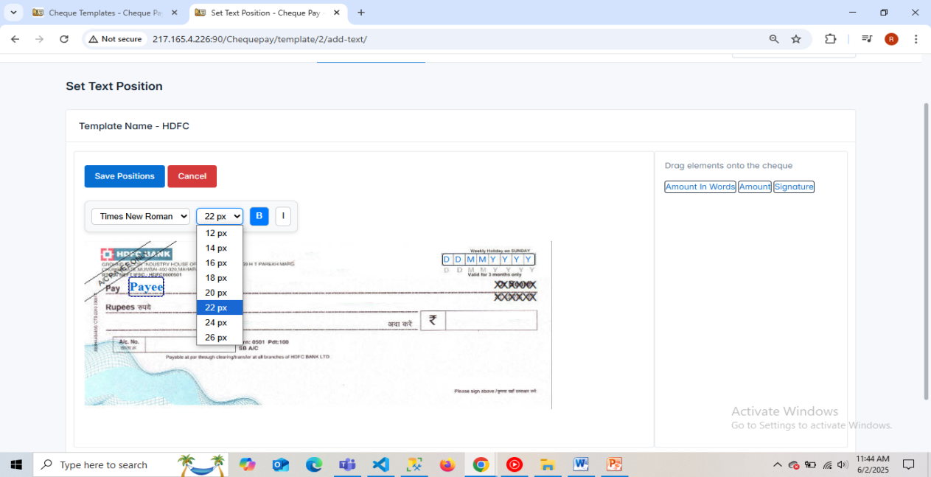

* Display of text positions set on the template and to also remove/reset the texts.

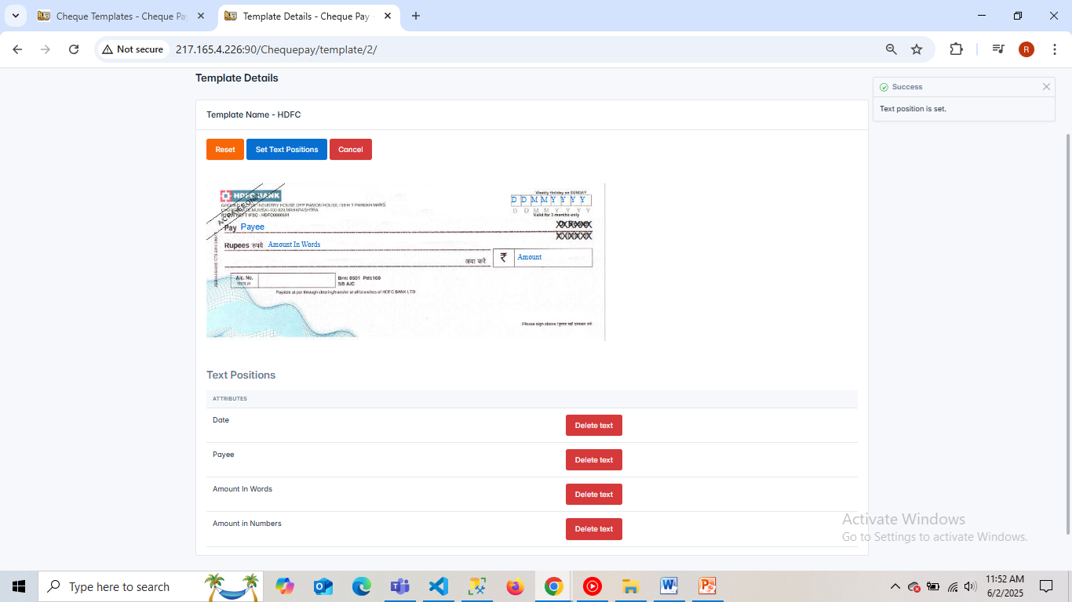

* **Issued Cheques**

This option shows the details of the issued Cheques – to approve/reject the issued Cheques and preview/print the approved Cheques according to the template used to issue the Cheque.

* Issued Cheques list

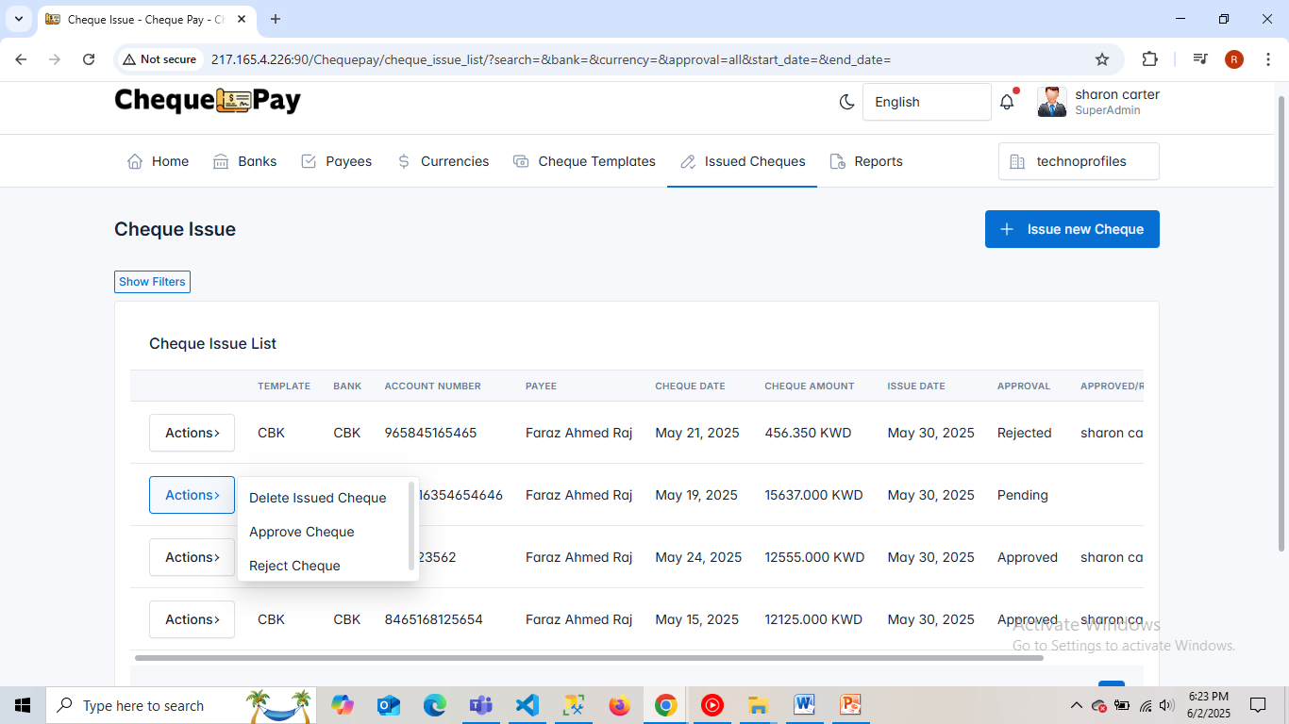

* New form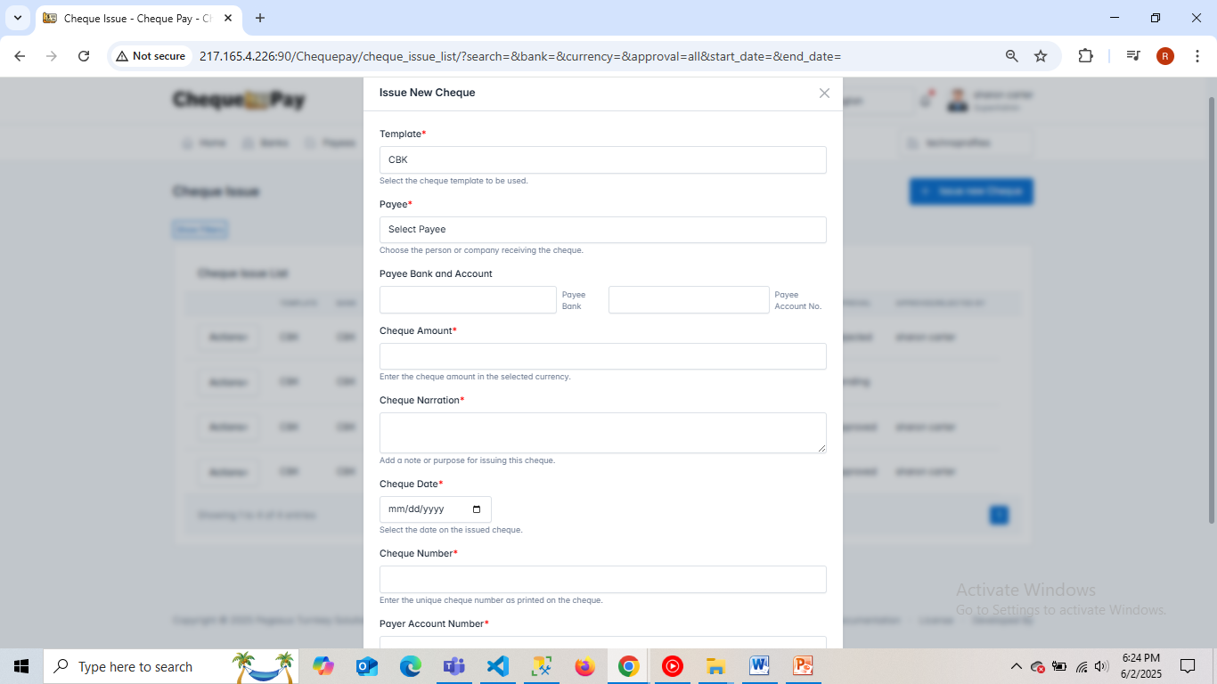
* Preview of approved Cheque.

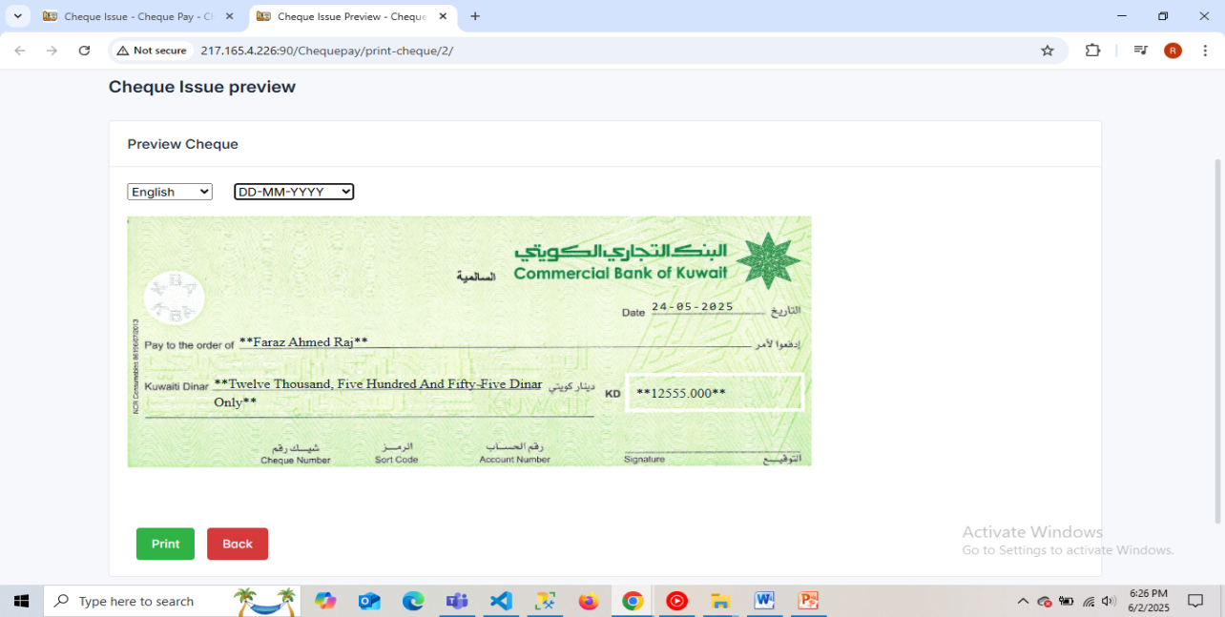

* To print the previewed Cheque after the modifications in the printer page setting matching Cheque template size.

